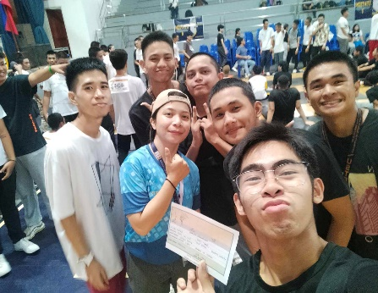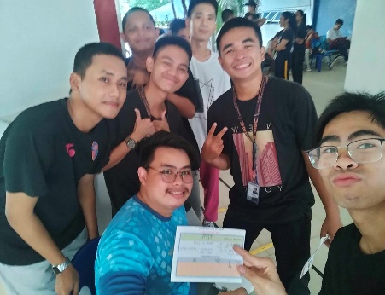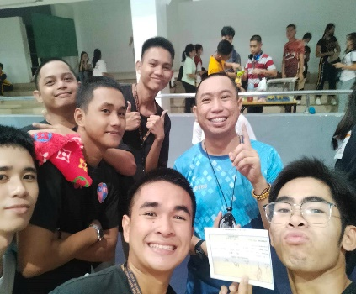Harry T. Zarate

BS I.T IT1R15

REFLECTION PATHFIT CHALLENGE 1

My journey in our activity in PATHFIT CHALLENGE in our physical education program, it helps our body maintain the good health. It enhances our strength, muscle and bone to be come a body fit, but in our activitys I face struggle because I don’t have exercise this past few months, so that I really struggle of some exercise like plank, jumping, but thanks god I finish all the stage that nothing happened bad to myself.

My PATHFIT CHALLENGE 1 journey help me realize that something I discovered about my physical activity that I know that I can’t do it, but I finish all the stage with no retreat. I believe in myself that I can do this challenge, just believe in myself even though I have no exercise.

This journey is the best journey I ever encounter in my Physical Education Program help me realize that being an athlete is not easy because in our PATHFIT CHALLENGE is just a normal exercise, just to boost our good health and physical health I really enjoy my PATHFIT CHALLENGE 1.